Area Assembly members react to proposed district lines

By Robert Harding | Posted: Sunday, January 29, 2012 11:06 pm

The proposed redistricting maps released Thursday could change how Assembly districts that include Cayuga County look, as well as the number of members representing the county in the Assembly.
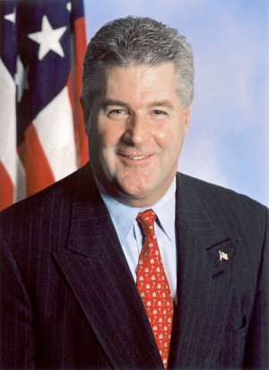

Maps could mean two Assembly districts include parts of Cayuga County -- the 126th and 130th Assembly districts. Assemblyman Gary Finch, who currently represents the 123rd Assembly District that includes Auburn, would represent the 126th. This district would include all of southern Cayuga County and Auburn.

Assemblyman Robert Oaks would represent the 130th Assembly District. This district would include all of northern Cayuga County.

That leaves Assembly Minority Leader Brian Kolb, whose district currently passes through the county. But if proposed maps are approved, Kolb would be the odd man out. His district would no longer include part of Cayuga County.

Kolb said in an interview Thursday that this is far from a done deal based on his experience.

"This is about the people, not about the Legislature," Kolb said. "It's not supposed to be what you like. It's about what the people want and representing the voters. It's not about Brian Kolb or any other legislator. I don't get too upset about it. Until we get to voting on it, it's just another exercise until we get to the final product."

Finch, Kolb and Oaks all acknowledged that the majorities, not the minority party, have the most say in redistricting. Oaks, who represents the Assembly Republicans on the Legislative Task Force on Demographic Research and Reapportionment, said significant changes were made to maps after they were first proposed 10 years ago and the same thing could happen here.

"My goal is that in the end the final districts reflect the best representation for the state and the region as a whole," he said.

But for all three members, they support an independent redistricting commission. Despite his service on LATFOR, Oaks said he thinks the state would be "better served" if an independent redistricting commission was in place. Finch agreed, saying an independent body should handle the redrawing of district lines.

"I think there should be an independent committee or an independent body that actually looks at these populations and draws these lines and doesn't gerrymander everybody all over the place. That would be in the best interest of everybody that lives in New York State," Finch said.

AD-123, AD-128, AD-129

